**Programming Fundamentals (CS1002) | Fall 2023**

**Assignment No. 01 Solution**

**Instructor: Prof Umer Haroon**

**Question No. 01:**

1. Begin with the number 0.
2. For each number from 0 to 10, do the following:
3. Multiply the number by itself to get the square using the formula **number * number**
4. Multiply the number by itself twice to get the cube using the formula **number * number * number**
5. Write down the number, its square, and its cube.
6. Move to the next number in the sequence.
7. Repeat steps 2 and 3 until you reach 10.
8. You're done when you've found the squares and cubes for all the numbers from 0 to 10.

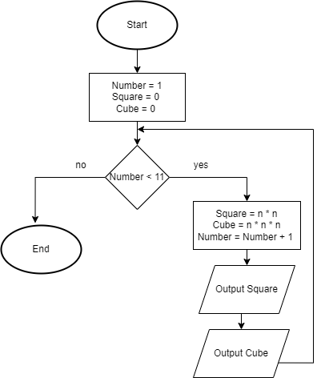

0

**Question No. 02:**

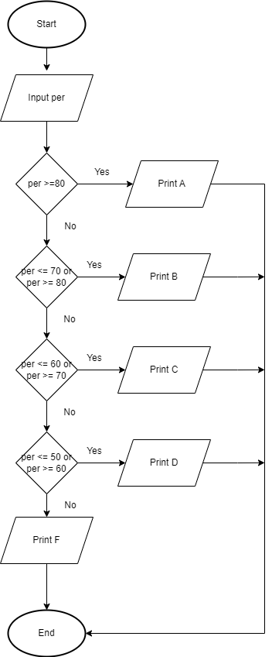

**Question No. 03:**

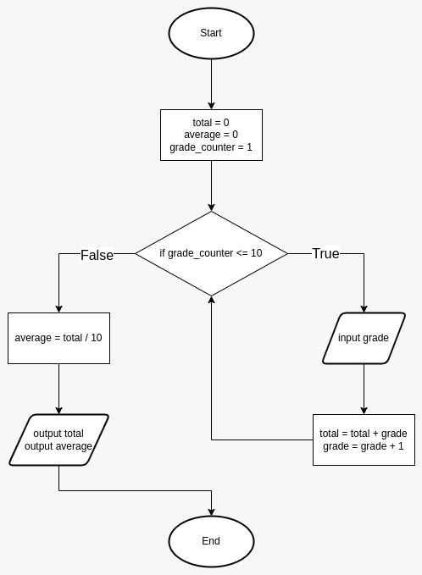

**Question No. 04:**

1. Start
2. Ask the user to give you a word and remember it as 'word'
3. Create an empty word called 'reversedWord'
4. Count how many letters are in 'word' and remember it as 'length'
5. Starting from the last letter of 'word' and going backward to the first letter, do the following:
   1. Add each letter to the 'reversedWord'
6. If 'word' is the same as 'reversedWord', then:
   1. Tell the user, "It's a palindrome."
7. Otherwise:
   1. Tell the user, "It's not a palindrome."
8. End

**Or (Easy approach)**

1. Start
2. Take a word
3. Rewrite the word in reverse order
4. Compare the original word with the rewritten word
5. If they are the same
6. Then the word is palindrome
7. Otherwise, it isn't a palindrome.

**Question No. 05:**

1. Begin
2. Ask the user to enter a positive number and call it 'num.'
3. If 'num' is less than or equal to 1, then:
   1. Tell the user, "It's not a prime number because it's less than or equal to 1."
4. Create a flag called 'isPrime' and set it to true
5. Create a variable called 'divisor' and set it to 2
6. While 'divisor' is less than the square root of 'num,' do the following:
7. If 'num' is evenly divisible by 'divisor,' then:
   1. Set 'isPrime' to false
   2. Exit the loop
8. If 'isPrime' is still true, then:
   1. Tell the user, "It's a prime number."
9. Otherwise:
   1. Tell the user, "It's not a prime number."
10. End

**Or (Easy approach)**

1. Take a number n
2. Divide that number by all the numbers from 1 to n,
3. If only two numbers completely divide the n, then it is a prime number.
4. Otherwise, it's not a prime number.

**Question No. 06:**

**(1)**

|  |  |  |  |  |  |
| --- | --- | --- | --- | --- | --- |
| Engine | Count | Number | Size | Average | OUTPUT |
| 3 | 1 | 1 | 3 | - | - |
| 5 | 2 | 2 | 2 | - | - |
| 6 | 2 | 3 | 1 | - | - |
| 11 | 3 | 4 | 5 | - | - |
| 11 | 3 | 5 | 0 |  |  |

**(2)**

|  |  |  |  |  |  |
| --- | --- | --- | --- | --- | --- |
| Engine | Count | Number | Size | Average | OUTPUT |
| 0 | 0 | 0 | 3 | - | - |
| 3 | 1 | 1 | 3 | - | - |
| 5 | 2 | 2 | 2 | - | - |
| 6 | 2 | 3 | 1 | - | - |
| 11 | 3 | 4 | 5 | - | - |
| 11 | 3 | 5 | 0 | - | - |
| 11 | 5 | 5 | -1 | 2 | 2, 3 |

**Average: 2, Output: 2, 3**